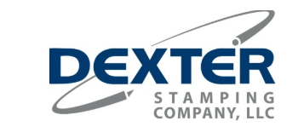

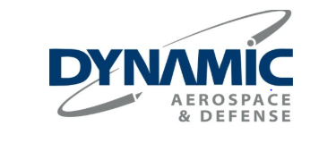

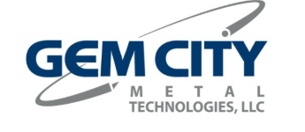

THE DYNAMIC GROUP

In June 2018 Hydram became part of the Dynamic Aerospace and Defense group.

As a group of tightly coordinated companies, Dynamic Aerospace and Defense is uniquely qualified to meet the technical and manufacturing challenges of its customers worldwide. Recognised for excellence in metal forming and fabrication, the group is focused on providing engineered solutions for customers’ metal forming needs.

CONTENTS

HYDRAM

Hydram is a leading subcontract sheet metalworking company supplying precision metal products, components and light fabrications throughout the UK and Europe.

Located in an 115,000 square foot factory in County Durham the company has grown steadily since it was established in 1977 with over 300 employees and significant investment in the latest production machinery.

Hydram partner blue-chip companies such as Caterpillar, Hitachi Rail, Alexander Dennis and Herman Miller to offer manufacturing solutions to meet their own and their customer’s needs.

**WATERMARK OF UK/US MAP**

*WATERMARK OF UK/US MAP*